**Lab 12**

**VPC Peering Lab – 1 of 3**

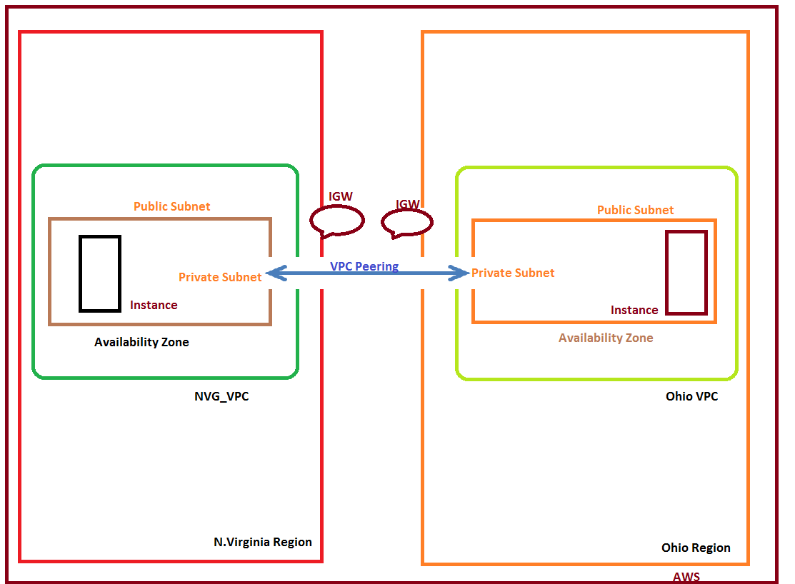

Scenario:

In AWS, regions are not communicate by default. Our scenario is to connect private networks between two regions by configuring VPC Peering.

In VPC Dashboard, click create VPC

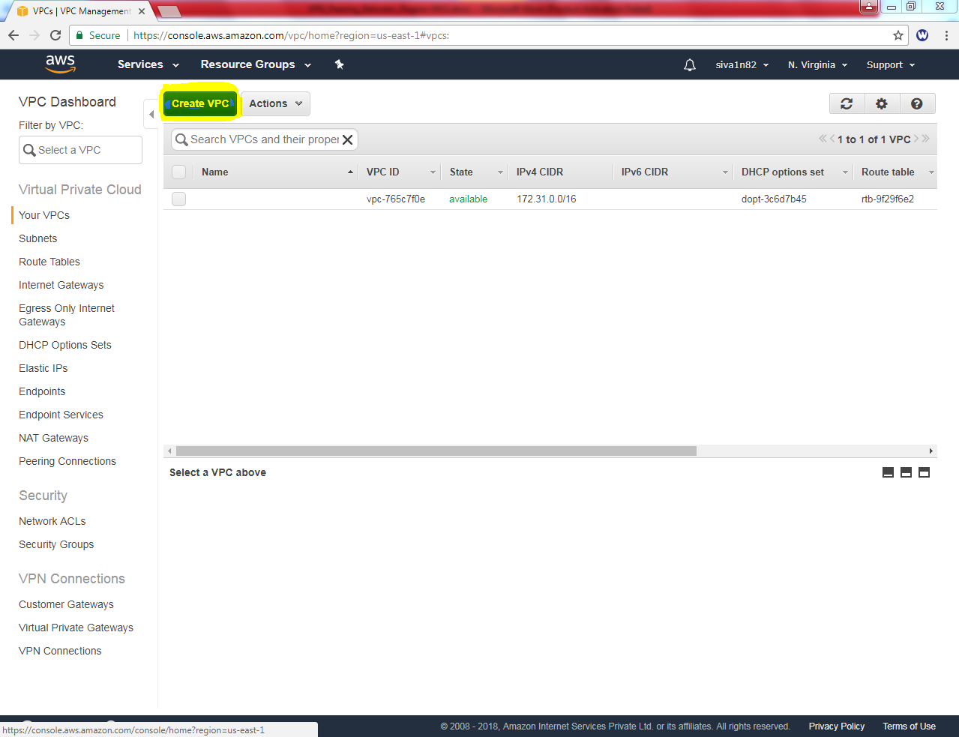

While create VPC, **Name tag** as “Sansbound_VPC” and **IPV4 CIDR Block** as 10.0.0.0/16

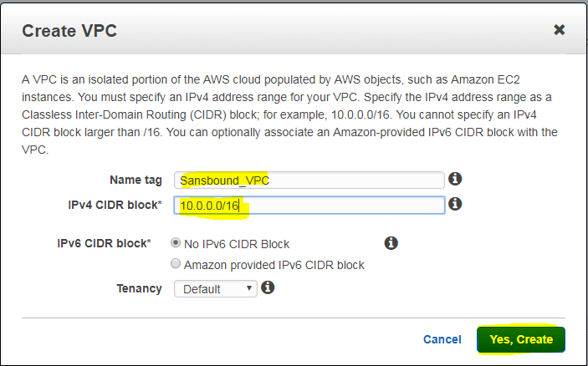

Then click “Create”.

Then we need to create subnet for the VPC.

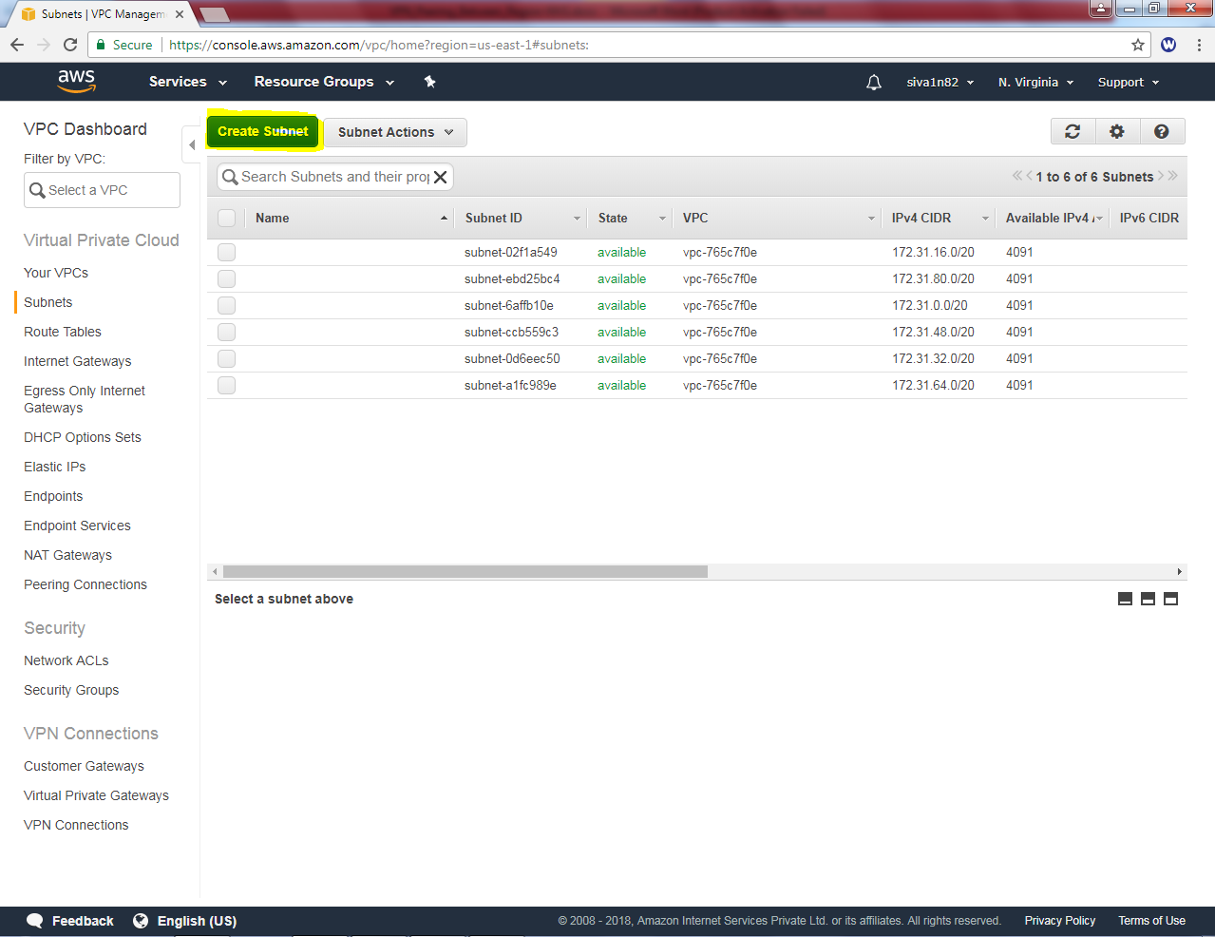

While creating subnet, **Name tag** as Sansbound_Public_subnet, **VPC** as “Sansbound VPC” **Availability zone** – 1B (Optional) and **IPV4 CIDR Block** as 10.0.2.0/24.

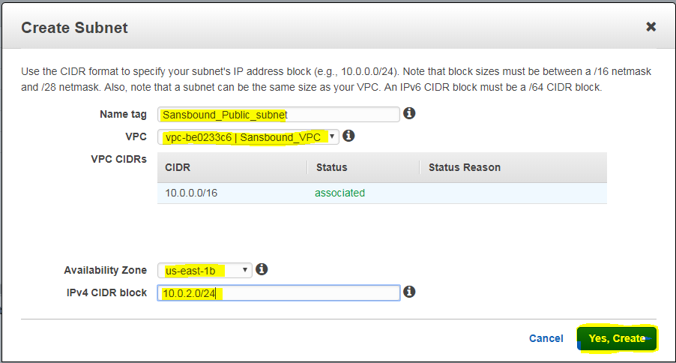

Then click “Yes, create”.

We need to create internet gateway to access the internet and connect the server publicly.

Click “Create Internet Gateway”

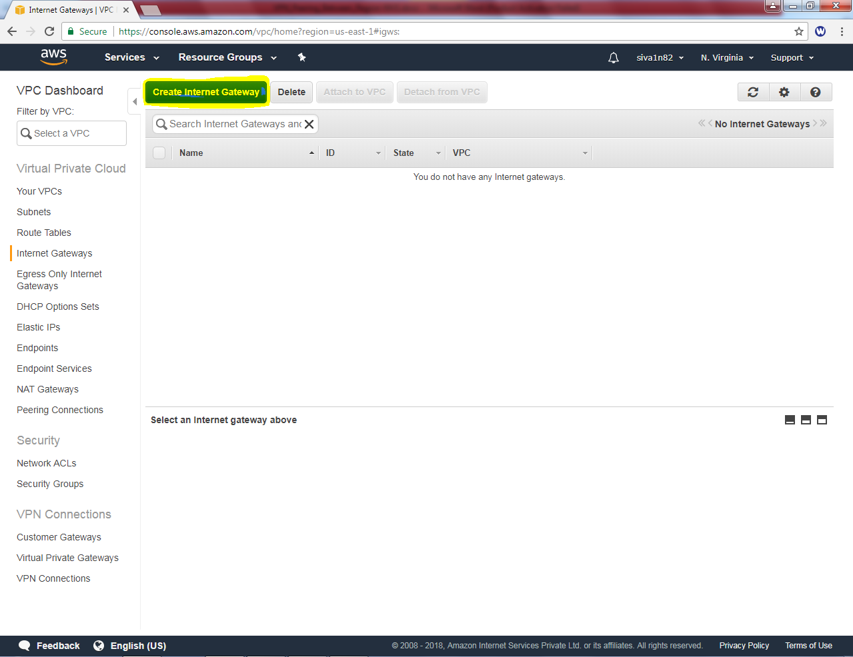

In **Name tag** “Sansbound IGW” and then click “Yes, create”.

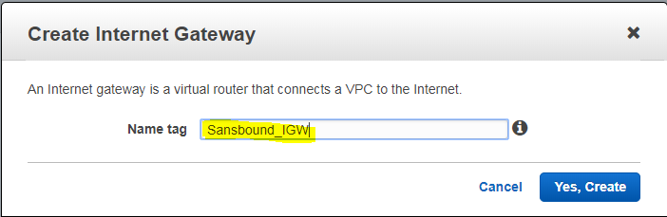

In Internet gateway, it’s in detached state, we need the attach the VPC.

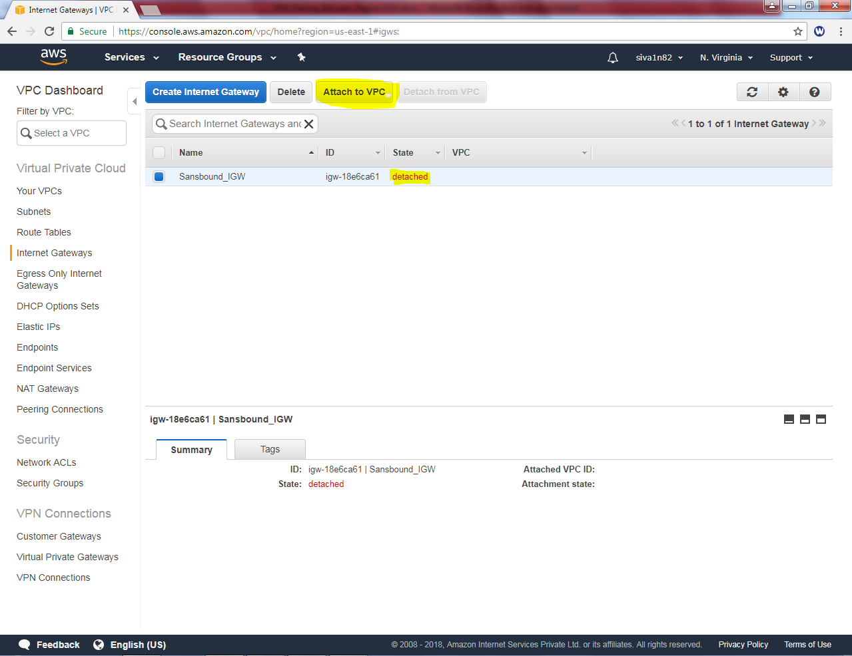

Click “Yes, attach”.

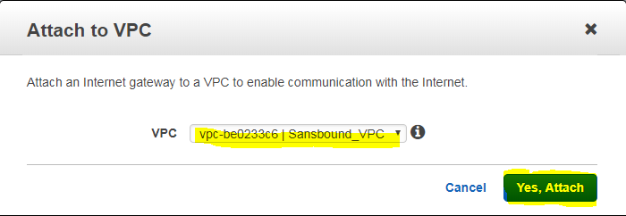

In Routing table, click Need to the rename the Sansbound VPC table as Sansbound Public route.

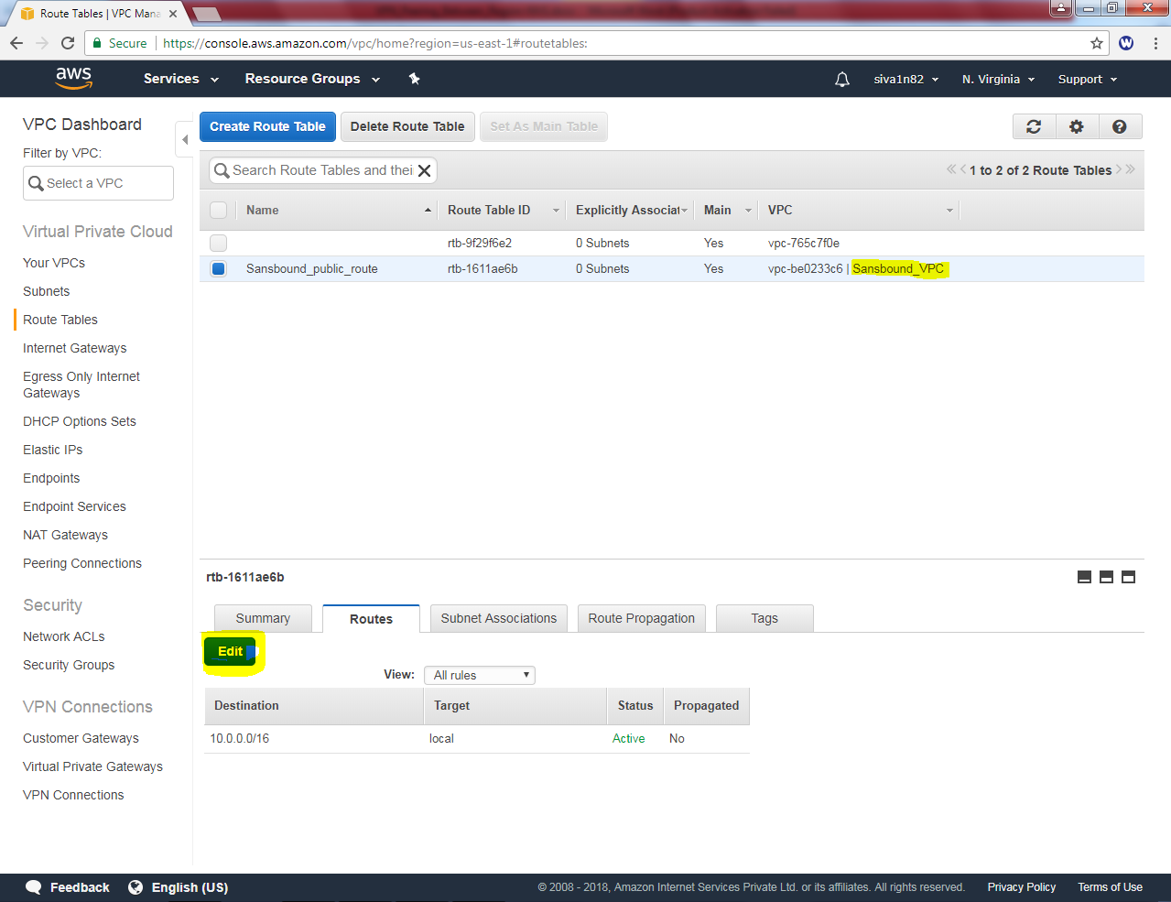

Then click “edit” option in route

Click “Add another route” option in route.

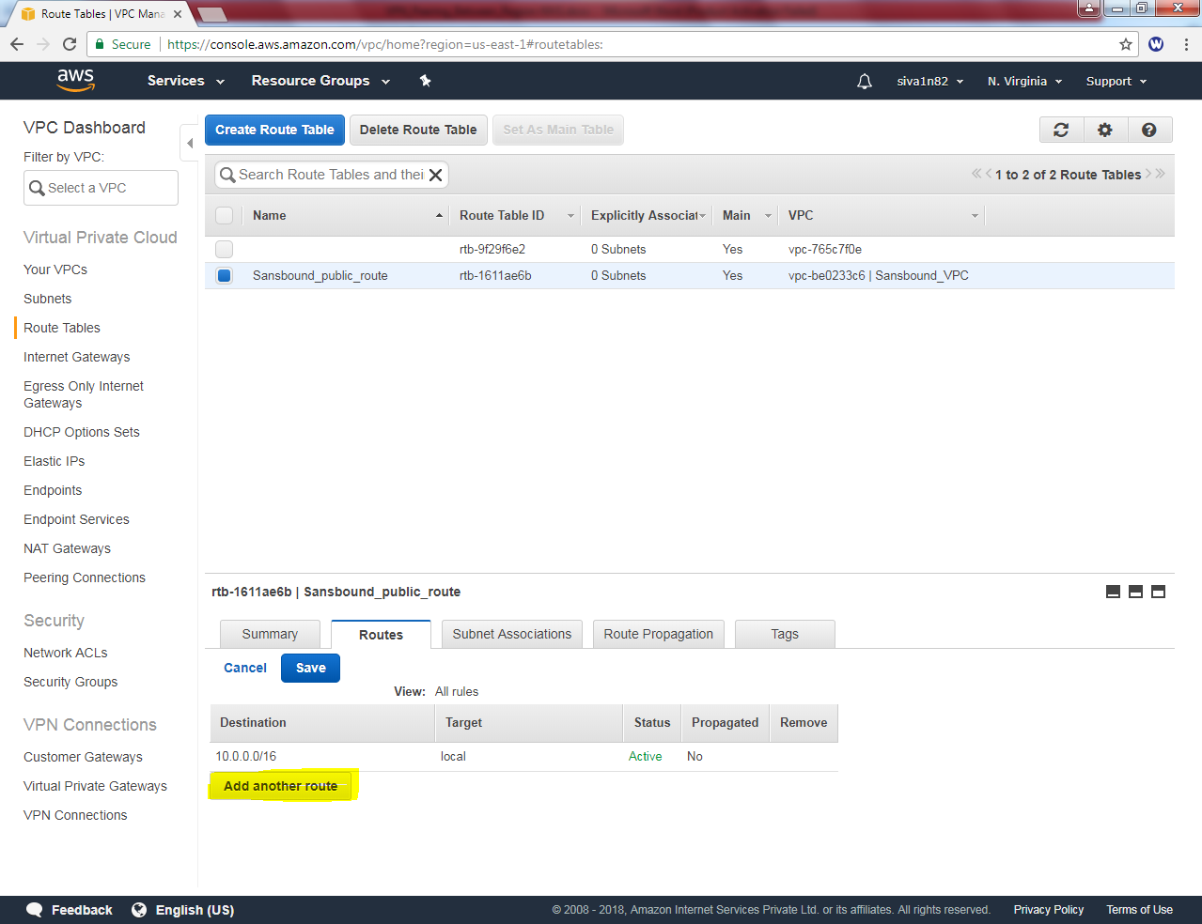

Add default route 0.0.0.0/0 and select **igw-\*** as target.

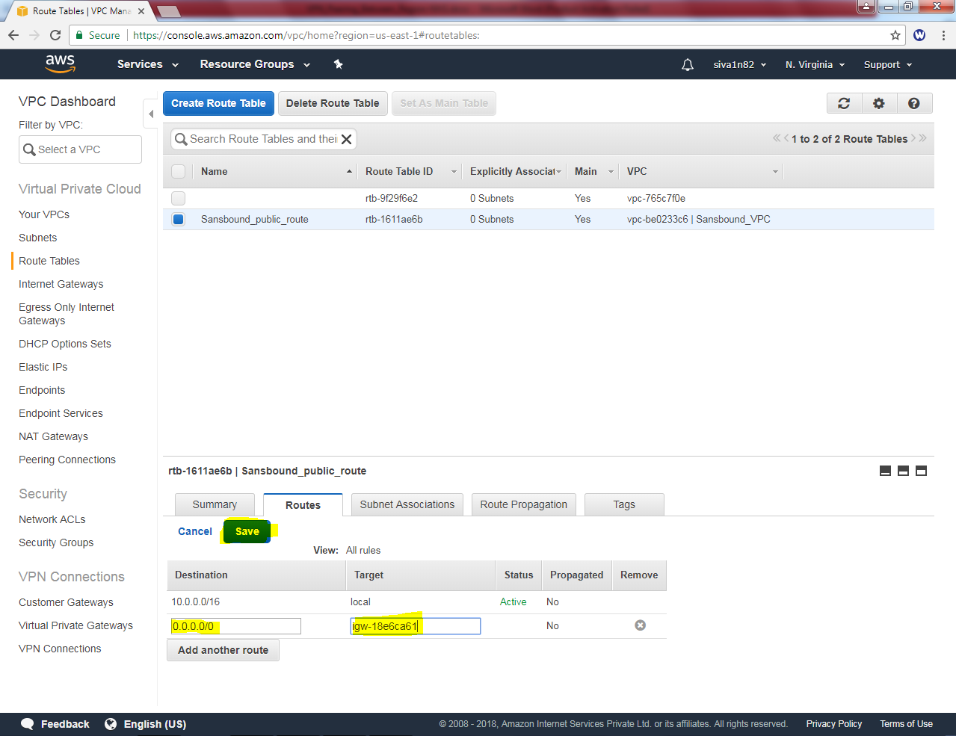

Then click “save”.

In “Subnet associations” click edit option.

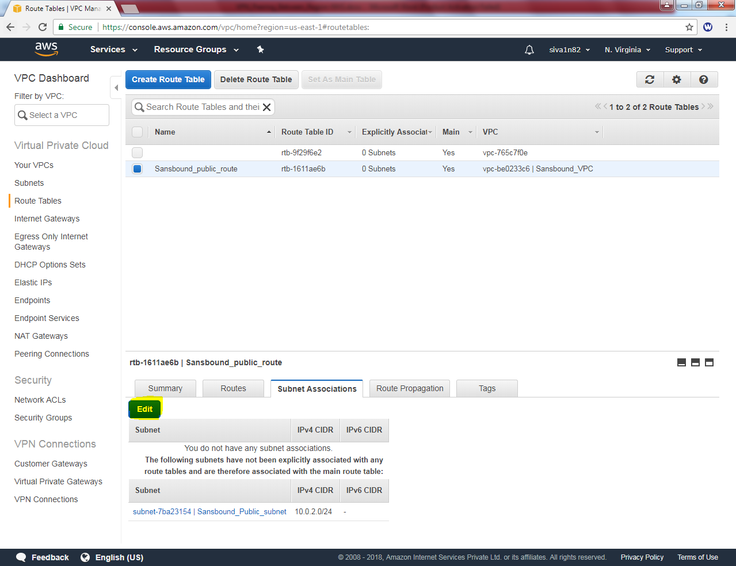

In Subnet associations select check box in “Sansbound Public Subnet”

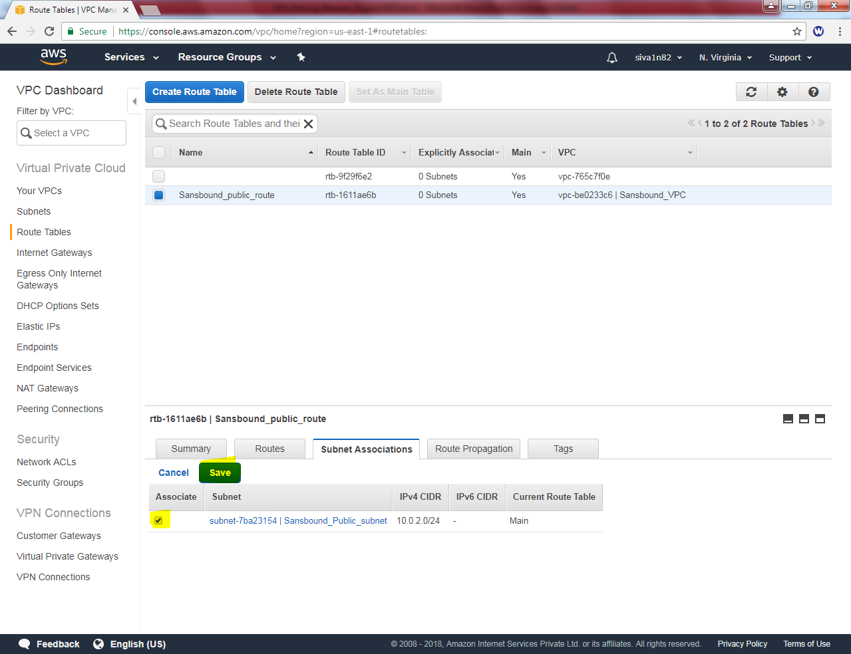

Click “Save”.

Now we need to create an instance (windows 2016) in North Virginia.

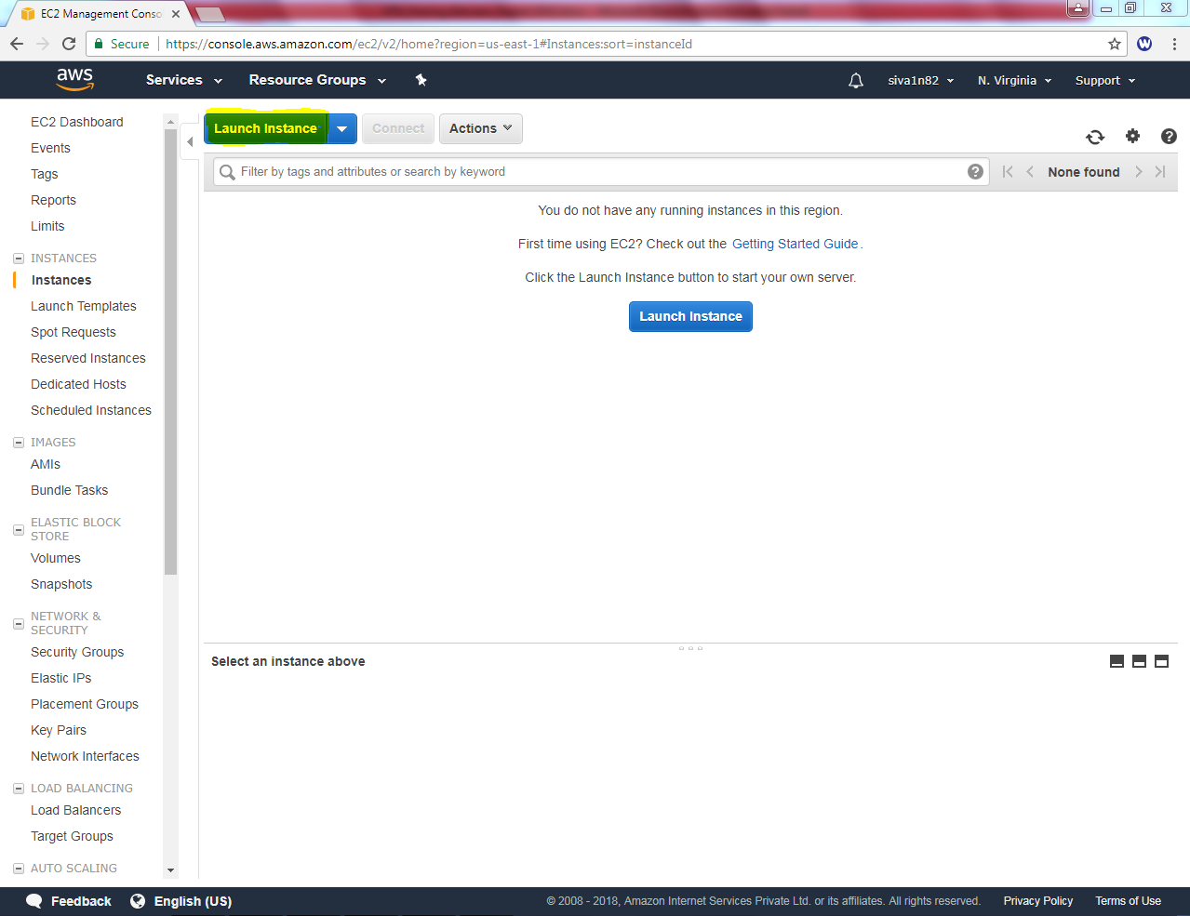

Select “Microsoft Windows Server 2016 Base”

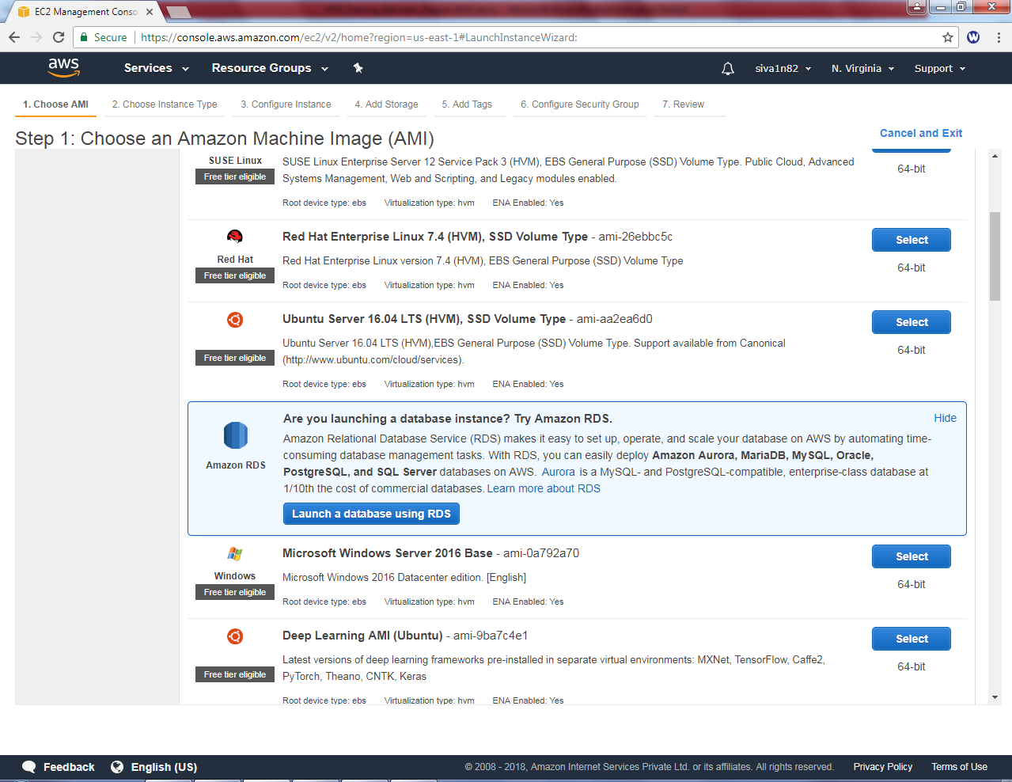

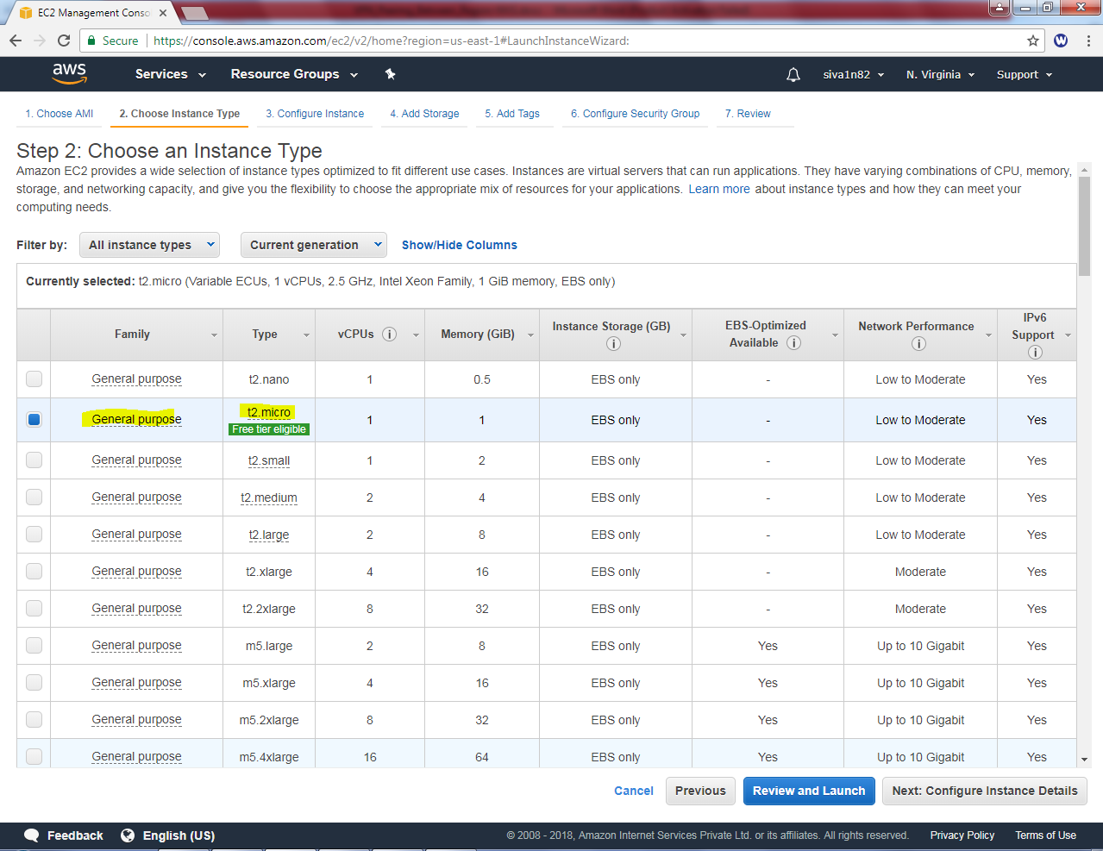

Select VPC as Sansbound_VPC

Select subnet as “Sansbound_Public_Subnet”.

Auto assign Public IP : Enable

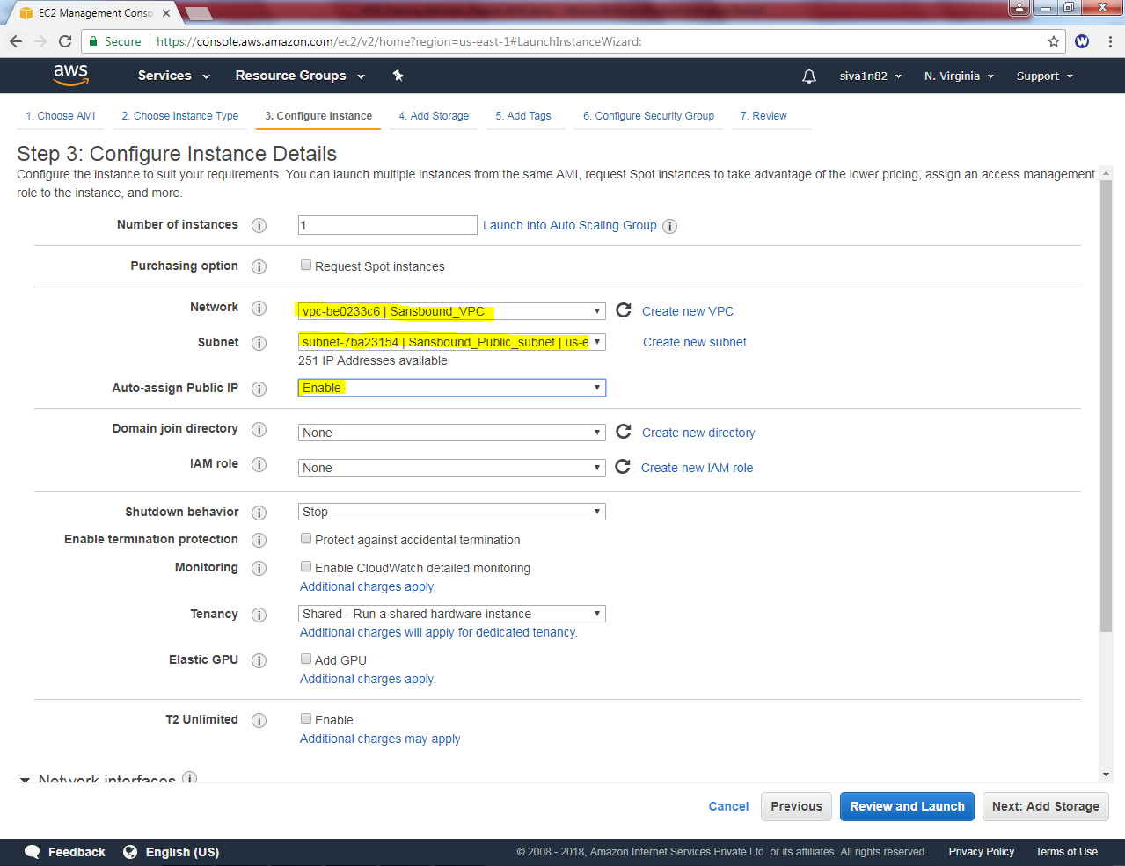

Leave default settings and click “Next”.

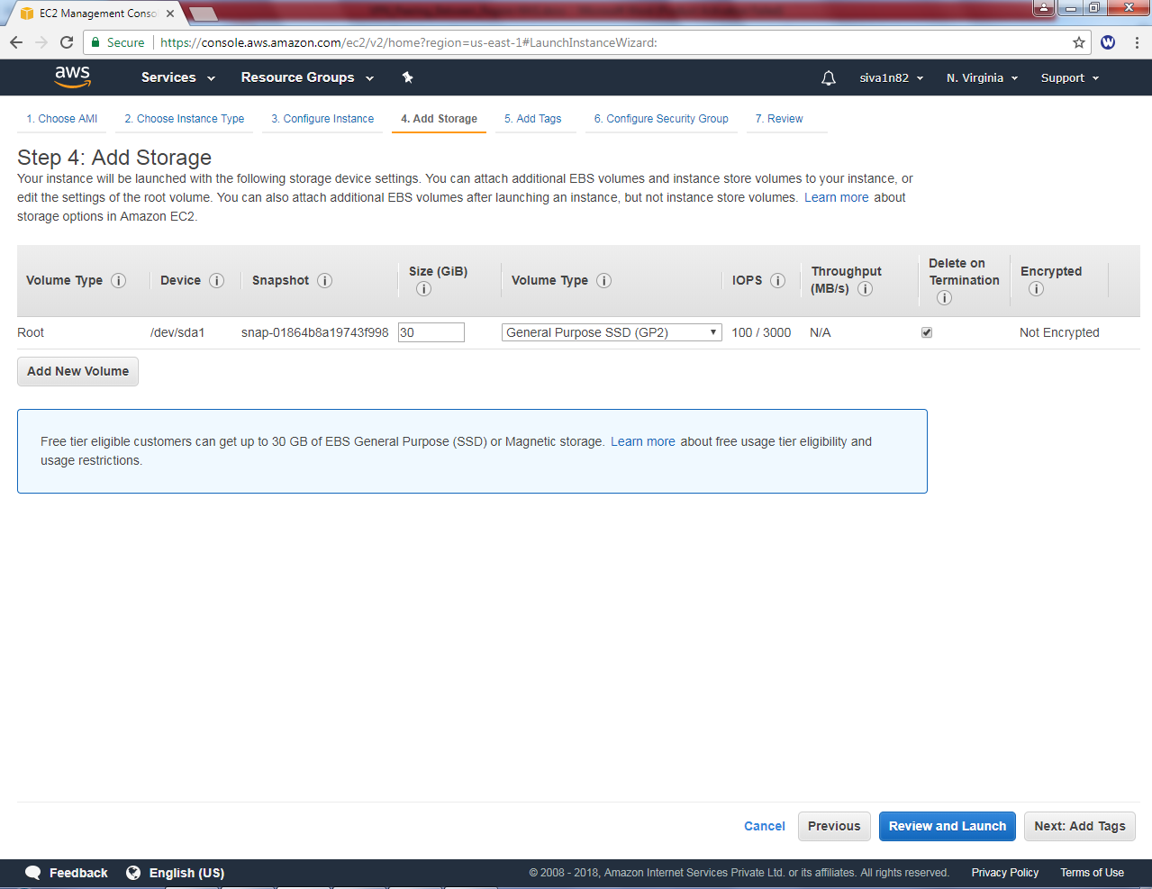

Type key as Name and value as “North Virginia Public instance” and then Click “Next”.

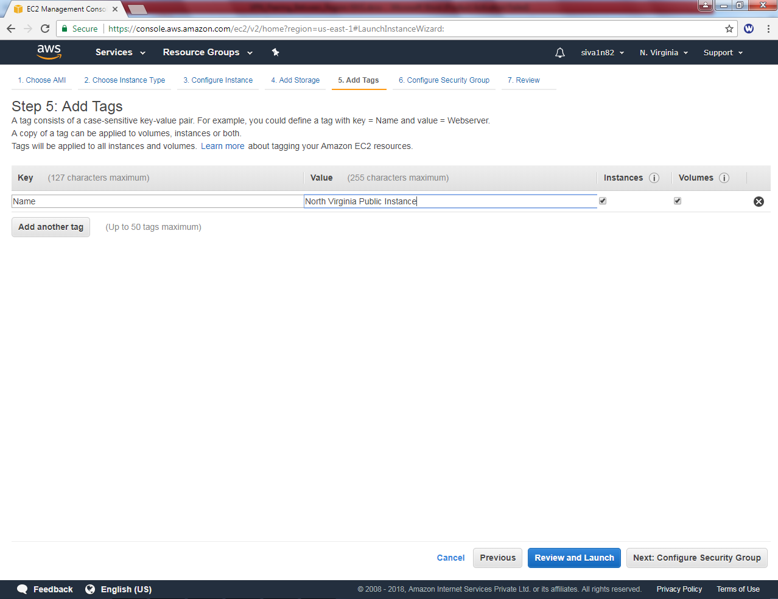

Create a new security group as “NVG_Public_Sec_Group”.

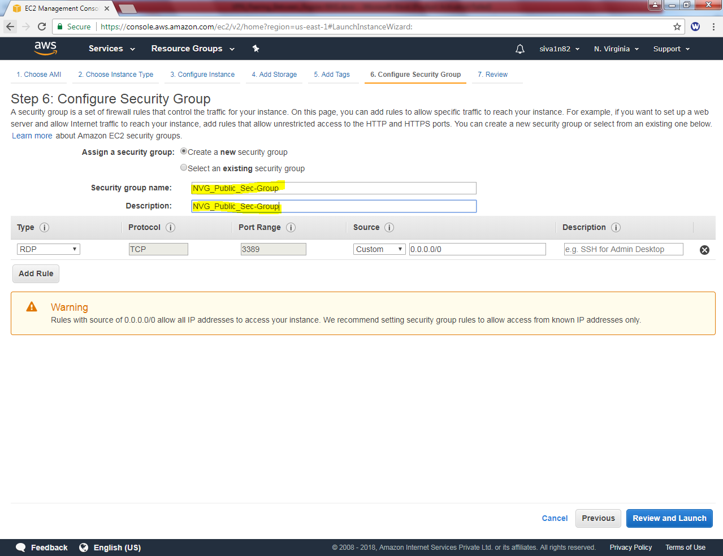

Click “Review and Launch”

Click “Launch”.

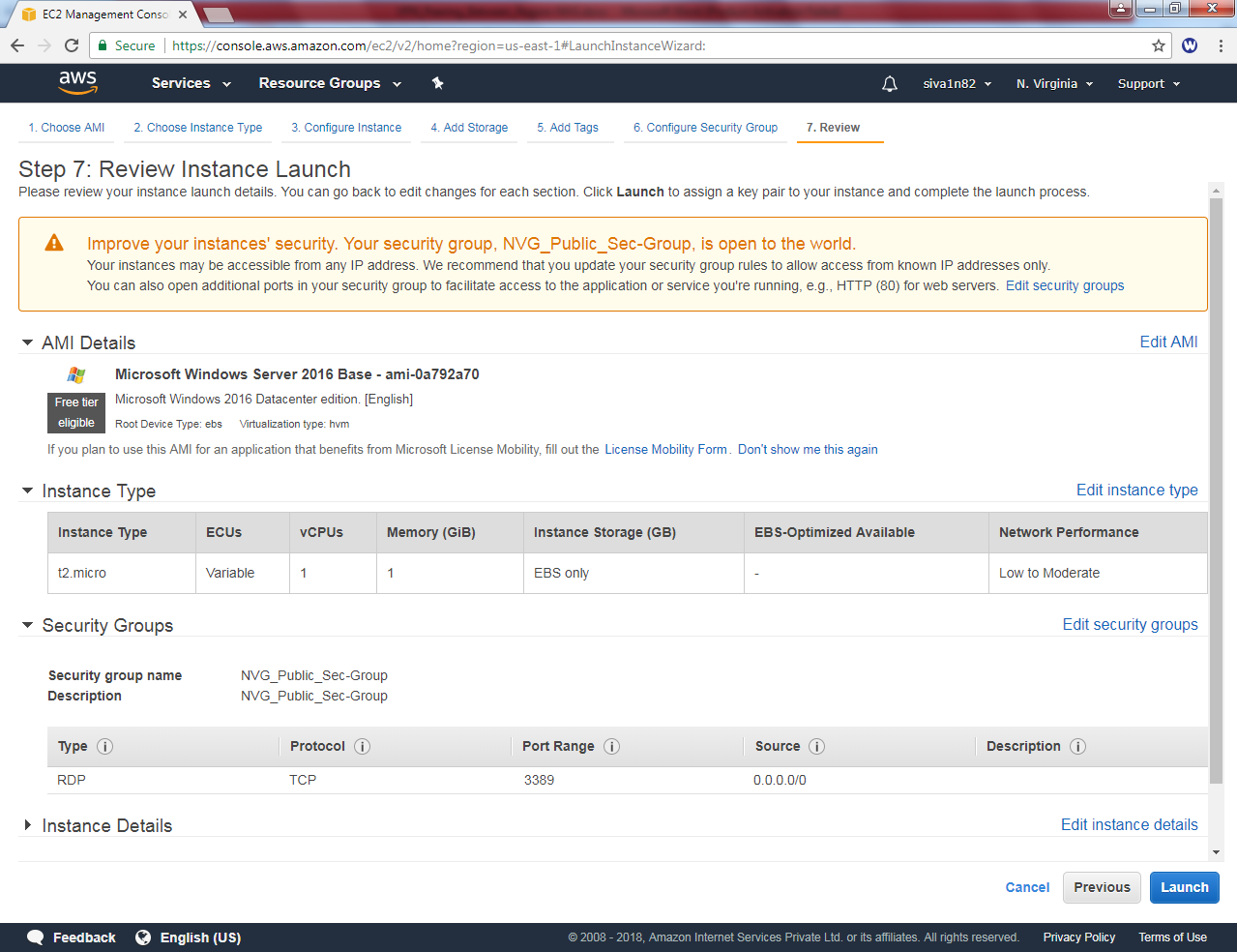

Select an existing key pair or create a new key pair.

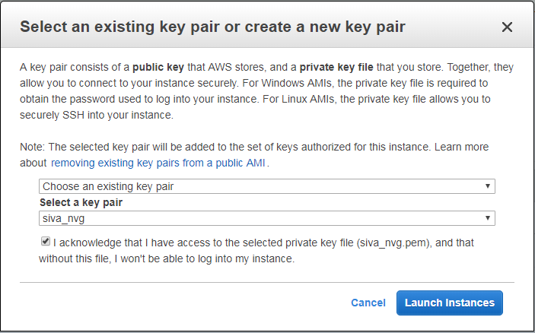

Choose an existing key pair and select the key pair.

Then click “Launch instance”.